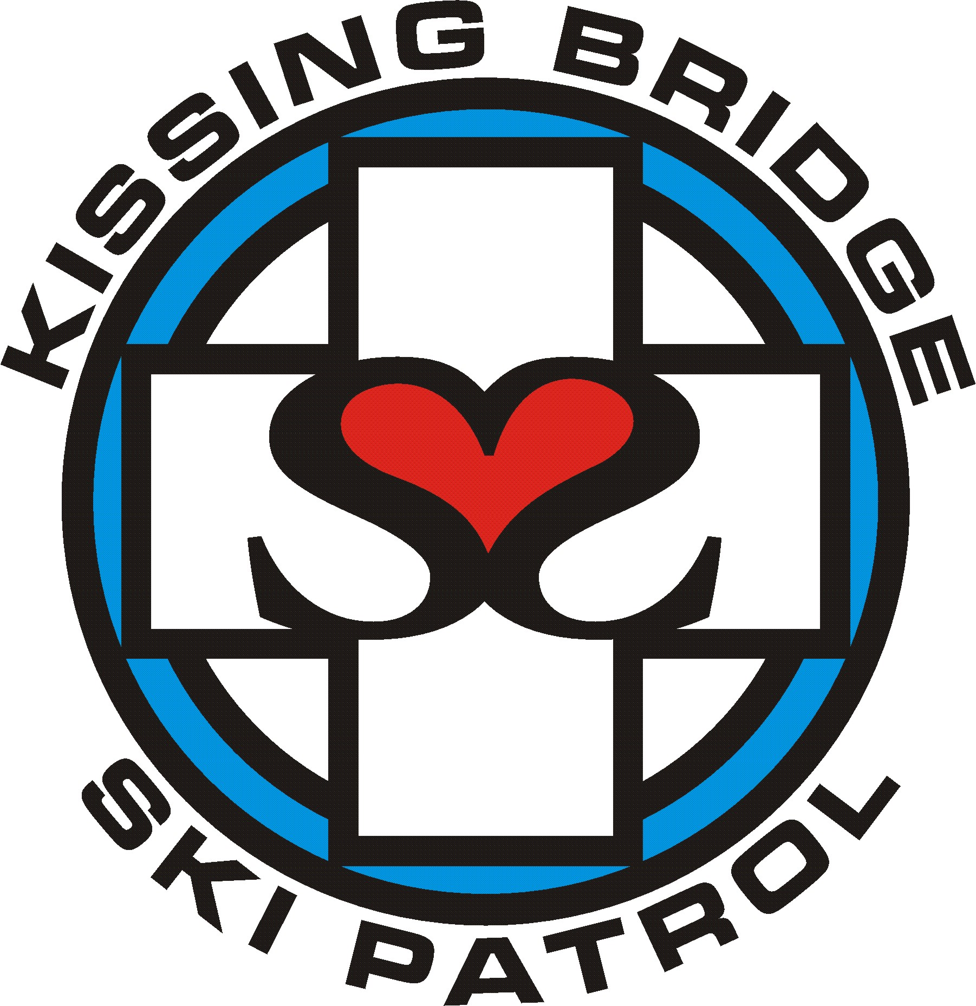 | Kissing Bridge Ski Patrol  Candidate Application

Date:

Name:

date of birth: |  | social security number:

Address:

City: |  | State: |  | Zip:

home phone: |  | CELL phone:

EMAIL:

OCCUPATION: |  | WORK PHONE:

PLACE OF BUSINESS:

First Aid Information
- Do you have any first aid/emergency care certifications or instructor status?
Yes No
If yes, please elaborate
- Have you had practical medical experience?
Yes No
If yes, please elaborate

Snow Sports Experience
Alpine (downhill) skiing | years | times per year
Telemark skiing | years | times per year
Snowboard | years | times per year

Additional information
Have you been a Ski/Snowboard Instructor, member of a Racing Team, taken Ski/Board lessons?
Yes No
If yes, please elaborate

Other

- Please list hobbies, organized sports, teaching experience, other training, etc.
- After the training year will you be available to Patrol during the day on weekdays?
Yes No

- Have you ever been an employee of Kissing Bridge?
Yes No
If yes, in what capacity?
What was your reason for leaving?

- Why do you want to join the Patrol?
- Did anyone refer you to the Patrol?

Thank you for your interest in the Kissing Bridge Ski Patrol. We will contact you with the date of our first meeting.

Return this completed application to:

Diane Smith
Patrol Director
Kissing Bridge
12617 Vaughn St.
East Concord, NY 14055

